Names ______________________________________________________________________________
EDUC 2551 – Elementary School Math: Geometry
Project 3

1. A swimming pool is pictured below. Each end is a semicircle and middle section is a rectangle.
a. If you were to take a walk around the edge of the pool, how far would it be?
b. What is the area of the pool?
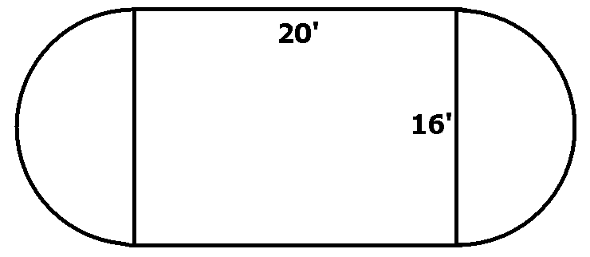

2. The following questions pertain to the figure below.
a. If each side has a length of 1 unit, find the areas and perimeters of L1, L2, and L3
b. Draw L4 and find its area and perimeter;
c. What is the formula for the perimeter of Ln?;
d. What is the formula for the area of Ln?
e. Find the area and perimeter of L10.
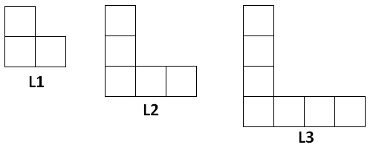

3. a. Find the area of the triangle.
b. Find the perimeter of the triangle
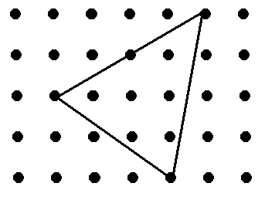
c.. Draw a line segment that is length of exactly $\sqrt{41}$units on the square dot grid below.

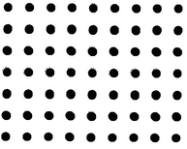

4. a. A square is inscribed in each of the circles below. The radius of circle A is 1 and the radius of the circle B is 2. What is the
ratio of the area of the square inscribed in circle A to the area of the square inscribed in circle B?
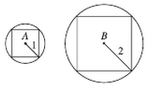
b. The circle shown has a diameter of 6. Find the shaded area.
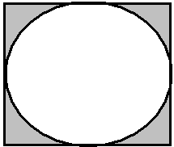

5. Find the sinA, cosA, and tanA.
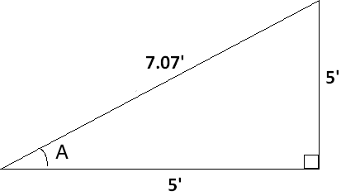

6.




